 | BELLOWS CONTROLS SERVIÇOS AERONÁUTICOS.  COM 1712-31/ANAC  FICHA DE TESTE FCU
Unidade: FCU |  | P/N: 4138008-3 | S/N: F76626
Modelo: DP-F2 |  | Data: 03 / 02 / 2023 | O/S: BEL 0029 / 2023
Cliente: AERO CHAPADÃO |  |  | Pag: 1 de 9
Manual*: 3244872 | Rev. 2 | Data: Nov. 18, 2020 | ATA: 73-20-64

TEST SPECIFICATION Nº AETS 71187 - Rev. A

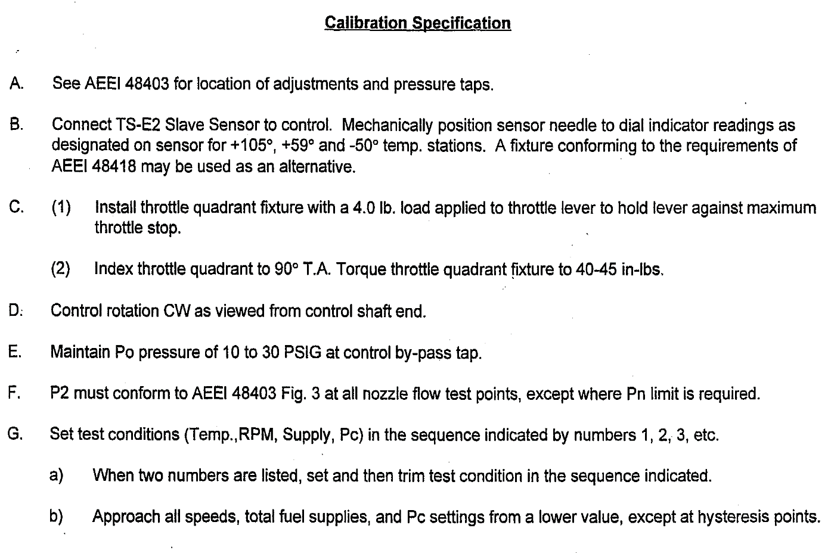

H. All adjustments are to be properly torqued.
Test points indicated (*) require special attention and are to be checked following proper torquing.

1. | Metering valve orifice torque | 35 |  | 40 in. Ibs.
2. | By-pass setting torque | 25 |  | 35 in. Ibs.
3. | Min. M.V..stop (breakaway) torque | 4 |  | 20 in. Ibs.
4. | Max. flow M.V. stop torque | 20 |  | 25 in. Ibs.
5. | Max. gov. eccentric torque | 7 |  | 7.5 in. Ibs.
6. | Max. throttle, stop torque | 20 |  | 25 in. Ibs.
7. | Idle speed stop torque | 20 |  | 25 in. Ibs.
8. | Flow body to drive body | 20 |  | 25 in. Ibs.
9. | Drive body adapter to drive body | 25 |  | 30 in. Ibs.  in 5 in. Ibs. increments
10. | Py Bleed | 9 |  | 11 in. Ibs.
11. | Man. Override stop nut | 20 |  | 25 in. Ibs,

I. Speed for Test Points indicated by (#) is to be set to + 2 RPM of specified value. All other points are to be set within + 20 RPM of specified value.
J. Total supply is to be set to ± 20 PPH of the specified value or within limits when shown.
K. Before calibration, check for external air leakage using M73/9. Slow bubbling is permitted at the joint of drive body and flow body, at the joint of drive body and drive body adapter, at the torsion shaft cover and at the bellows and torsion shaft Iocknuts. No leakage is permitted at any other point. Pc = 100 psia. If leakage is considered excessive, measure Px-Py when Pc = 100 psia, RPM = 0, and T/A = Max. Px to be measured at the bellows ratio lever cover.
Px- Py = ± 1.2" Hg. Maximum

L. Maintain manual override fully C.C.W, except where otherwise indicated.

1.01 | CHECK RELIEF VALVE OPENING  (a) Cap outlet port.  (b)Increase fuel flow until supply is within limits specified and observe P1-Po differential.  (c) If P1-Po differential is out of limits, shim as required.  Add shims to increase differential.  1 5 2 3 4  0 200-275 MAX +105 85.0  Relief valve opening P1-P0 950 1000 psi
1.02 | CHECK PRESSURIZING VALVE OPENING  (a) Outlet line connected to control.  (b) Increase supply pressure with outlet port open, observe start of nozzle flow.  (c) If P1-Po is out of limits, shim as required.  Add shims to increase differential.  1 5 2 3 4  0 100 MAX +105 85.0  Pressurizing valve opening P1-P0 55 68 psi  If valve cover has been removed and reassembled, torque screws to 4.5 - 5.0 in-lb, in 1 in-lb, increments maximum while alternating between the screws.

METERING VALVE ORIFICE AND BY-PASS HEAD (P1-P2) "HG SETTING
(a) Test points 2.01 thru 2.03 are interrelated and should be recorded after all three (3) adjustments have been made.
(b) If at T.P. 2.03, P1-P2 is higher than 41 in. Hg, remove by-pass valve cover and replace existing spacer PIN 3240905 with thicker spacer PIN 3240905-1. If P1-P2 is lower than 33 in. Hg., remove and discard existing spacer.
(c) Re-torque the by-pass valve retaining screws to 20 in-lb in increments of 5 in-lb and recalibrate T.P.2.01 to 2.03.
2.01 | 3 4-6 1 2 5  5800 1350 MAX +105 40.0  203 212  Adjust head and orifice, P1-P2 = 26-42 in HG.
2.02 | 3 4-6 1 2 5  2900 720 30-32 +105 40.0  80 84  Pn = 75-90 psig  Set minimum MN stop after removing Py line. Open back pressure valve.
2.03 | 3 4-6 1 2 5  5800 1350 MAX +105 70.0  367 373  Retrim head and re-adjust 2.01 – 2.02 if out of limits  P2= 365 415 psig  Pc-Px 1.0 in Hg. Max  Px-Py 1.2 in Hg. Max  As per note (b), check appropriate box.  Original spacer  Spacer removed  Spacer replaced
2.04 | 3 4-6 1 2 5  5800 1350 MAX +105 100.0  Set maximum M/V stop  506 520
2.05 | 3 4-6 1 2 5  5800 1350 MAX +105 40.0  -10 +10

 | ENRICHMENT SPRING SETTING
3.01 | 3-7 4-6 1 2 5  5800 1350 MAX -50 55,0  X X Record Nozzle Flow
3.02 | 3-7 4-6 1 2 5  5100 1170 MAX -50 55,0  -13 -17  Adjust enrichment spring to obtain 13 to 17 PPH less than 3.01. Increasing spring tension increases difference. To verify setting, approach enrichment speed from 4600 RPM. (Re-check T.P. 3.01 & 3.02 after Adjustment)
4.01 | 3 4-6 1 2 5  4000 1000 MAX -50 40,0  172 183 Pn= 100-110 psig.  Pc-Px 8.5 11.5"HG  Px-Py 1.2" HG Max.

MAX. GOVERNOR SPRING SETTING
(a) Adjust eccentric shaft to meet flow limits.
(b) If unable to set with eccentric, maximum T.A. may be varied within T.A. limits.
(c) If unable to set with eccentric or maximum T.A. maintain eccentric shaft scribe line and determine amount of RPM off.
(d) Split control and adjust gov. spring as required. (CW adj. of governor spring delays break, approximately 1 flat on adj. nut per 50 RPM).
(e) If gov. slope is not in limits, select Py bleed. PIN 2525107

Py #58 #66 (higher number bleed to increase difference in flow).
5.01#* | 5 4-7 1 2 3-6  6350 1440 +59 85.0  325 355  Set governor break T.A, at 89° - 91° Px-Py "HG
5.02#* | 5 4-7 1 2 3-6  6500 1530 +59 85.0  X X  105 125  Diff. from T.P. 3.01 (Gov. slope)
5.03 | 5 4-7 1 2 3-6  1440 " +55 85.0  X X  Hysteresis within -50 0 RPM of T.P. 5.01 Px-Py "HG

IDLE SPEED STOP SETTING AND PICK-UP ANGLE
(a) At test point 6.02 Increase T.A. until 4 PPH max. fuel flow from 6.01 is observed. (T.A. where flow starts to increase is pick-up angle).
If throttle cam pick-up angle is out of limits, replace governor spring.
(1) • Use a higher numbered spring if pick-up angle exceeds 56 ° diff. from T.P. 6.01.
(2) Use a lower numbered spring if pick-up angle is less than 52 ° diff. from T.P. 6.01.
(3) Adjust spring tension to same load as set on spring removed.
(4) Re-set gov. break at test point 5.01 and rerun T.P.'s 5.02 and 5.03 inclusive.
(5) Re-set idle stop screw at test point 6.01.
6.01 | 4 1-7 5 2 3-6  3200 800 30-32 +59 30.0  104 112  Set idle stop screw (CW adj. to increase flow). Decrease and re-set speed after adjustment throttle pick-up angle.

6.02 | 4 1-7 5 2 3-6  3200 800 +59 30.0  Pn = 95 - 105  Throttle pick-up angle difference 52° 56° of T.P. 6.01  Spring Stripe

LOW END OF ACCELERATION FLOW AND THROTTLE MOVEMENT EFFECT
(a) After recording nozzle flow at test point 7.02 move throttle to 30° T.A.
(b) Observe nozzle flow change and record.
7.01 | 3 5 4 2 1  815 200 40 +59 Local  60 X Pn= 75 psig
7.02 | 3 5 4 2 1  2100 670 40 +59 25.0  113 124  Pn= 95-105 psig  Move T.A. to 30° 5 PPH maximum decrease

 | MAX. IDLE RESET STOP ADJ
8.01 | 1 4-6 5 2 3-7  5000 1170 - +59 55.0  188 197  Set Max. idle reset stop. Record T.A.

MANUAL OVERRIDE
At test point 9.01 set max. manual override flow.
Rotate override lever C.W. and maintain in contact with max. flow adjusting screw. Rotate adjusting screw C.C.W. to increase flow.
9.01 | 1 5 2 3 4  5000 1170 32 +105 AMB.  405 415
9.02 | Record manual override total angular travel  94° 104°

CUT-OFF MODULATION AND CUT-OFF LEAKAGE
A. At test point 10.01, set test condition with 20 ° T.A.
(a) Move throttle to 30 ° T.A. and observe nozzle flow change.
If nozzle flow change is excessive -
(1) Reset throttle to 20 ° T.A.
(2) Back off override adj. nut on cut-off link.
(3) Adjust cut-off link longer to meet max. flow change limit.
10.01 |  | 3 4-6 1 2 5  2000 500 20 +105 A.R.  160 170  Nozzle flow change 4PPH max.
B) At test point 10.02 check cut-off leakage.
(a) Remove nozzle outlet from control.
(b) Set total supply with throttle in cut-off position. (Highest T.A. position where no leakage is observed at outlet fitting).
(c) Increase T.A. to permit flow out the outlet fitting.
(d) Decrease T.A. as required until no leakage is observed at outlet fitting (Observe T.A.).
(e) Same Pc as established for T.P. 10.01.
10.02 | 3 4-6 1 2 5  2000 500 8-10 +105 -  P1-P2  0 0.5 cc/min. Cut-off leakage  P1 pressure 250 psig max.
C) At test point 10.03 (-5 ° T.A.).
(a) Observe P1 pressure.
(b) Upper lever (idle reset lever) stop to just contact lever.
(c) At 0 ° T.A. lower C.O. lever to be within ± 5 ° of horizontal.
(d) Pc same at T.P. 10.01.
10.03 | 3 4-6 1 2 5  2000 500 -5 +105 AR  P1 pressure equal to or less than T.P. 10.02 P1 psig

10.04 | 3 4-6 1 2 5  Min-Max-Min Local  Operate throttle. Lever over full range.  Throttle torque 15 in-lb max.

EXTERNAL LEAKAGE CHECK
A. Cap Po at drive flange by-pass tap.
B. Remove Po line to control and install Po plug.
C. Cap outlet port.
D. Set P1 pressure to 1000 PSIG.
E. Observe leakage for 2-3 minutes.
F. No leakage permitted.

11.01 | OK REJECT
11.02 | Record shipping weight X 5.3 lbs.max
Checado por :____________________
Carimbo/Rubrica
Inspecionado por:_______________________
Carimbo/Rubrica
Data de encerramento do teste:______________________

